
Flood Map Update

East Hanney

Important information about flooding in your area

What is the Flood Map?

The Flood Map is a guide to areas of land that are at risk from flooding from rivers and should prompt those who live near a river to be aware and find out more.

Being in the Flood Map does not mean your home or business will flood. Equally some properties may flood in the future but may not currently be in the Flood Map outline.

We have a statutory responsibility for flood risk management and defence in England and Wales and support the planning system by providing timely information and advice on flooding issues. Our Flood Map contributes towards this and is updated every three months with new data if available.

What has changed?

We have carried out a detailed study to gather new information to improve our Flood Map in your area.

In your area approximately 10 properties have been reassessed to be at higher risk. On the other hand, about 91 properties have been reassessed to be at low risk from flooding and have been removed from our Flood Map altogether.

Am I affected?

Check whether your property now lies within the Flood Map.

Our Flood Map will be updated by 21 December 2009 at www.environment-agency.gov.uk/homeandleisure/floods/31656.aspx

If it is within the dark blue outline called ‘Flooding from Rivers and the Sea’, it has a 1 per cent chance of flooding in any year. If it is within the light blue outline called ‘Extent of Extreme Flood’, it has a 0.1 per cent chance of flooding in any year.

Or call Floodline on 0845 988 1188 after 21 December 2009.

Will this affect my insurance?

Insurance companies use the Flood Map and the National Flood Risk Assessment to help them set the cost of insurance cover. However, they also use their own knowledge and information. If the flood risk to your property has changed, you may see a change in the cost of your insurance premium in the future.

As we have updated our Flood Map, we are reviewing the National Flood Risk Assessment. We hope to publish the results in early 2010. In the meantime insurance companies will rely more on their own information to decide a premium.

What should I do?

Talk to your insurance provider

We have no role in determining insurance cover or setting premiums. If you think your insurance premium will change or that the assessment of your property is now wrong, you should speak to your insurance provider to find out what information they need to support your view.

This may include evidence that:

- your property is set higher than known flood levels;
- all occupied areas of the house are set above known flood levels; or
- either you or your community have taken action to reduce flood risk.

It may help you to read the Association of British Insurers’ booklet Flood Resilient Homes, which is available free of charge at www.abi.org.uk

Be prepared

Read our leaflet Preparing for a flood: Practical advice on what to do to protect you and your property to help limit the damage that flooding can cause. You can find it on our website at www.environment-agency.gov.uk

Sign up to our free flood warning service

Our flood warning service, Flood Warnings Direct, is free. In order to register for our service, either visit our website at
https://fwd.environment-agency.gov.uk/app/olr/home
or phone our Floodline service on 0845 988 1188 and speak to the operator.

When registering, you can choose how you receive your warning. In all cases, you must provide a landline telephone number and you can then select any, or all, of the following additional contact methods: by text message to your mobile phone; by e-mail; by fax or by pager. We recommend providing a mobile telephone number in case you are away from home when flooding occurs.

When a flood warning is in force neither our website nor the warning message you might receive will give local flooding information. Local information is available from our Floodline service. In the first instance, you will need to phone Floodline on 0845 988 1188, select option one, then enter the Quick Dial Number for your area when prompted: 171045.

Maps showing the changes to the Flood Map

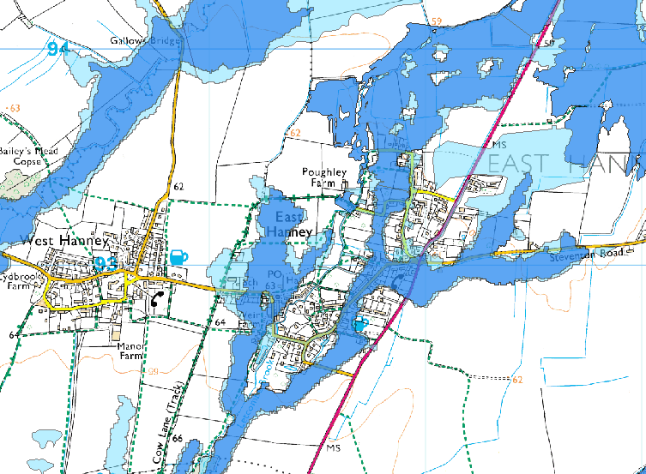
Before December 2009
Flooding from Rivers
Extent of Extreme Flood

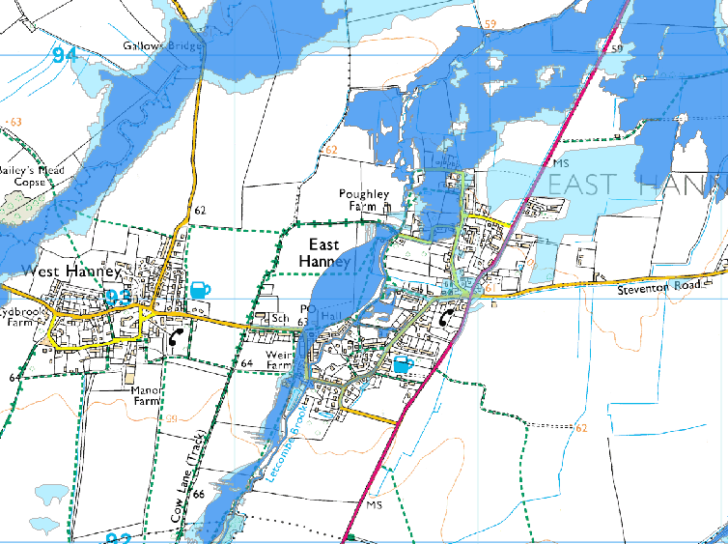
After December 2009
Flooding from Rivers
Extent of Extreme Flood

